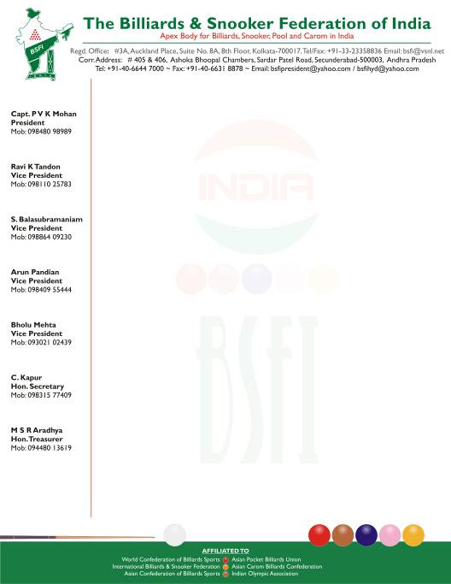
N O T I C E

To: All State Associations / Federations.
Sub: Accreditation of Players, Coaches & Officials

Dear All,

In the Management Committee meeting held at Indore on 2nd June 2007, the accreditation policy has been introduced and approved.

It is now mandatory for all players to be BSFI Accredited to be eligible to play in the National and International tournaments. The salient features of the policy are as follows:

- Players will be provided with accreditation kit comprising of Identity card, Accreditation certification, and a host of benefits they can avail.
- Federation will put up profile of accredited players on the website and will also assist players in availing employment and sponsorship opportunities.
- Enable players avail a host of benefits without any discrimination, like training, performance based incentives, evaluation and recognition through awards & medals, redressel of grievances etc.,
- Enable players to utilize infrastructure of the federation and its registered state members at no extra cost while on travel, touring or attending events. Etc..,

A complete copy of Accreditation policy is attached for your understanding.

All Players, Coaches and Officials are required to register at the earliest. Those registering before 30th September 2007 will be charged an early bird discounted rate of Rs.1500/- (Rupees One thousand five hundred only) as one time entry fee. From 1st October 2007 till 31st December 2007 the entry fee will be increased to Rs.2000/- (Rupees two thousand only).

In addition to the above entry fee there will be an annual membership fee of Rs.250/- (Rupees Two Hundred fifty only) to revalidate the accreditation every year.

The fee is payable by Demand Draft only and to be drawn in favor of The Billiards & Snooker Federation of India, Payable at Kolkata.

for The Billiards & Snooker Federation of India

Capt. P V K Mohan
President

The following Enclosures to be sent along with Application without which the application will not be considered
Players
- Latest Pass Port Size Photographs – 25 Nos.
- Color or Clear Xerox Copy of Passport
- Latest/updated Bio-data giving Details of Achievements
- Application duly signed by State Federation / Association President or Secretary

Coaches & Referees
- Latest Pass Port Size Photographs as below
    - Coaches - 25 Nos. ii. Referees – 10 Nos.
- Color or Clear Xerox Copy of Passport
- Latest/updated Bio-data giving Details of Achievements
- Application duly signed and stamped by the president or secretary of the State Federation / Association to which you belong to.

State Federation / Association’s Committee Members
- Latest Passport size photograph – 2 Nos.
- Application duly signed and stamped by the president of secretary of the corresponding state federation/association clearly indicating your designation/Position in the respective state association.
- Copy of Passport / Driving License / PAN card for identification proof

Other Members
- Affix Latest Passport size photograph on application
- Application duly signed and stamped by the president of secretary of the corresponding state federation/association clearly indicating your designation/Position in the respective state association.
- Copy of Passport / Driving License / PAN card for identification proof

:: Important Note ::

- The BSFI will relay and distribute important announcements, information, notifications, invitations on national / international events and meets to only accredited members directly on the email address provided by them
- The BSFI does not assure, distribute or share information with members who are not accredited with the federation.
- All the information provided with accreditation form will be kept confidential and will not be shared with any third parties.

